  **KIRINYAGA UNIVERSITY**

**SCHOOL OF PURE AND APPLIED SCIENCES**

**ONLINE TENANTS MANAGEMENT SYSTEM**

PRESENTED BY:

BRIAN MWANGI KAMAU

CT101/G/3084/17

PROJECT SUPERVISOR

Mr. KIRORI

A research project submitted to the school of Computing and information technology in partial fulfilment of requirement for the conferment of the Bachelor of Science in Information Technology, of Kirinyaga University

April 2019

**DECLARATION**

I BRIAN MWANGI KAMAU CT101/G/3084/17 of Kirinyaga University do declare that this project is my original work and has never been presented before in this institution or any other for academic purpose.

Name: BRIAN MWANGI KAMAU

Adm No. CT101/G/3084/17

Signature: ……………………….

Date: ……………………….

This project has been submitted for examination with my approval as the University Supervisor.

Supervisor’s name: MR. KIRORI

Signature: …………………………

Date: …………………………………….

# **DEDICATION**

I dedicate this project to my father and mother, my supervisor and all those who assisted me to doing this project both financially and emotionally

# **ACKNOWLEDGEMENT**

The satisfaction that accompanies the successful completion of any task would be incomplete without the mention of people whose ceaseless cooperation made it possible, whose constant guidance and encouragement crown all efforts with success.

My regards go to my project fellow course mates who gave me guidance, inspiration and constructive suggestions that were very helpful in the preparation of this project. I also thank all my lecturers since it is through the knowledge, they have shared with me that made this project a success.

I would also like to thank my parent due to their moral and financial support which has made me remain in the institution and complete the project successfully.

I also acknowledge my colleagues who have assisted with ideas whenever necessary and have made this project a success.

Above all am grateful to Almighty God for seeing me through the entire task.

# **ABSTRACT**

Online tenant’s management system is a web-based system designed to meet the information of renting firms. It gives solution to the landlord and/or caretaker of managing the tenants and the houses. Most firms do not have a computerized system to manage the houses and the tenants and thus they managed it manually. There was a problem of retrieving tenant’s information, overpayments and balances checking. All these problems and manual tasks were computerized and this makes the management easier. The system has the ability to automatically generate house information, tenant information, payment receipts and reduce manual paperwork. Existing systems which are similar to the project under study were reviewed. Waterfall methodology was used while developing the system. The documentation also shows the design of the system interfaces as well as design of the database where all the information used in the system is stored. The conclusion, limitations and the future work of the system are also outlined here.

**Table of Contents**

**DECLARATION** ii

**DEDICATION** iii

**ACKNOWLEDGEMENT** iv

**ABSTRACT** v

**CHAPTER 1: Introduction** 1

**1.0 Introduction** 1

**1.1 Background Information** 1

**1.2 Current/Existing System** 1

**1.3 Problem Statement** 2

**1.4 Proposed System** 2

**1.5 Purpose of the Study** 3

**1.6 Objectives** 3

**1.7. Justification** 3

**1.8** **Scope** 3

**1.9** **Limitations** 4

**CHAPTER 2: METHODOLOGY** 5

**2.0 Introduction** 5

**2.1 Development Methodology** 5

**2.2 Data Collection Method** 8

**2.2.1 Interview** 8

**2.2.2 Observation** 8

**2.3 Feasibility Study** 9

**2.3.1 Economic Feasibility** 9

**2.3.2 Technical Feasibility** 9

**2.2.3 Operational Feasibility** 9

**CHAPTER 3: SYSTEM DESIGN** 10

**3.0 Introduction** 10

**3.1 System Requirements** 10

**3.1.1 Hardware Requirements** 10

**3.1.2 Software Requirements** 10

**3.2 Process Design** 11

**3.2.1 Process Diagram** 12

**3.2.2 Use Case Diagram** 13

**3.2.3 Data Flow Diagram** 14

**CHAPTER 4: SYSTEM TESTING AND IMPLEMENTATION** 20

**4.1 Unit testing** 20

**4.2 Interface Testing** 20

**4.2.1 Landlord Login** 20

**4.2.2 Tenant Registration** 20

**4.2.3 Tenant Login** 20

**4.2.5 Integration Testing** 21

**4.3 System Changeover** 21

**CHAPTER 5: CONCLUSION RECOMMENDATION AND FUTURE WORK** 22

**5.1 Introduction** 22

**5.2 Conclusion** 23

**5.3 Project success** 23

**5.4 Limitations** 23

**5.5 Recommendation** 23

**References** 24

**Appendices** 25

**List of Figures**

Figure 2.1 Property Vista 5

Figure 2.2 Property Boulevard 6

Figure 2.3eFACiLiTY® Tenant Billing System 7

Figure 2.4 Truerent Online Management System 7

Figure 4.2: Home Page 19

Figure 4.3: Landlord Login 19

Figure 4.4: Landlord Dashboard 20

Figure 4.5: Tenant Registration 20

Figure 4.6:Payment recording 21

Figure 4.7:Database Tables 21

Figure 4.8:Tenants table 22

Figure 4.9: Houses table 22

Figure 4.10: Payments Table 23

Figure 4.11:Issues raised table 23

# **CHAPTER 1: Introduction**

## **1.0 Introduction**

The chapter entails the background of the system, shows the current or existing systems which are similar or almost similar to the developed system, the problem statement, the objectives, scope and the limitations of the proposed system.

## **1.1 Background Information**

Online Tenants Management System is a web-based system intended to replace the current manual paper system by providing efficient way of monitoring and managing tenants and houses for renting firms.

A tenant is a person who occupies property rented from a landlord (Malamud, 2017). The system enables the organization to track and record all information related to the houses and the tenants. The system allows the landlord or the caretaker to login and retrieve or update information.

## **1.2 Current/Existing System**

Many renting firms use manual systems whereby the tenants’ details are recorded and kept manually in a book. A page in the book is reserved for every tenant where all his/her information is kept. The landlord/caretaker who is the administrator of the system keeps record of the tenants in the whole firm. He has to know when a particular tenant joins the firm, how much he/she paid, the house number of the person and the amount payable every month. The administrator also has to balance the amount paid by the tenant, amount due and then determine whether the tenant has an overpayment or underpayment.

## **1.3 Problem Statement**

There is a lot of paperwork from acquiring tenant’s information to house allocation to payments and to receipt issuance. The firms cannot be able to trace the vacant houses unless one memorizes it. Payment of houses may take up to ten minutes for one person thus time wasting.

The manual system has a lot of errors which include things like double counting, arithmetical errors, long-time in retrieval of tenant’s information and it is unable to easily produce monthly statements of the money received from the tenants and the pending balances. There is so much paper work involved during tenants’ admission into the firm.

## **1.4 Proposed System**

Unlike the existing manual system which keeps tenants’ information manually, the developed system is web-based meaning that all information keeping and recording is automated. All the tenants’ details are kept in a database which is easily updatable, secure and reliable.

The system maintains two levels of users; the admin level and the tenants’ level. The admin level can only be accessed by the landlord or the caretaker. The admin can be able to track and record all information related to the houses and the tenants. The system allows the landlord or the caretaker to login and retrieve or update information. The tenants also can login into the system and view their profiles, payments record and any communications from the admin. Any complains and suggestions from tenants as well as communications from the admin are communicated through the system.

# **1.5 Purpose of the Study**

The purpose of the study is to come up with a system that automates the management process of tenants for renting firms.

## **1.6 Objectives**

The main objective was to develop a tenant management system that addresses all tenant issues.

**Specific objectives**

1. Developing a system which captures tenants and house details
2. Providing a platform that tenants can arise issues concerning their houses.
3. Providing an automated email notifications system to tenants on payments and status of issues raised.

## **1.7. Justification**

Most of renting firms use the manual way of recording their tenants' information where the manual system is not reliable due to many errors associated with it. The online system helps in generating monthly report for the firm as well as producing computerized receipts. The system avoids errors brought about by the manual system and reduces the paperwork involved. Determining the vacant houses has been made easy and house allocation has been automated and has facilitated easier communications between the admin and the tenants.

## **Scope**

This system has been developed to cover Highland Investment Limited which is a renting firm and has provided both the admin and the tenants view. The system covers all the renting activities carried out at Highland Investment Limited.

## **Limitations**

1. Every tenant must have a valid email address.
2. There must be internet connection to access the system.

# **CHAPTER 2: METHODOLOGY**

## **2.0 Introduction**

This chapter presents an overview of the methods used in the study. Area covered includes the research design, target population, data collection and analysis and the tools that were used for development of the system.

## **2.1 Development Methodology**

Waterfall model was used in developing the system where series of events were followed. The requirements of the system had to be determined through observation and interviews to determine user requirements and then design, implement, test and had to be maintained while it became operational. The system and structured analysis was then transformed into software design that is the software architecture to decompose the system into modules and representation of relationships among the modules, data structures and algorithms for the modules designed.

Implementation

System design

Requirement analysis

Deployment

Testing

Maintenance

Figure 5.1 Waterfall Model

1. Requirements analysis – This is the phase where system requirements are developed and documented in a software requirements specifications document. Users were required to give specific requirements which aided in creating the system that is most desirable to them.
2. System design – This phase develops a design for the proposed system by utilizing the system requirements. This phase helps in achieving specification of hardware and system requirements as well as the overall architecture.
3. Implementation – In this phase, each unit is developed and tested for its functionality and the developed modules of the system were incorporated to make a complete system. Verification of functionality of each unit was carried out in this phase. It also included coding. The system was implemented using PHP, HTML, MySQL, JavaScript and CSS.
4. System testing – In this phase all the units developed in the previous phase were integrated to form one system. Full system testing is done to and the entire system is tested for any faults and failures. This phase also involves systematic discovery and debugging defects. In this phase, the system was tested using real data to ensure that bugs are noted and correction done. System testing involved testing the system with extreme data to view how the system would respond. Any errors noted were solved in this phase.
5. System deployment - Once system has passed all the testing and removal of bugs is done, the system is released to the customer environment and released to the market. The system would be delivered with the full deliverable including the user manuals and system documentation.
6. Maintenance – This is the phase where issues coming up when the clients are using the system are addressed. This is the phase where errors those which did not arise during system testing were solved. It also involves users forwarding the errors they encounter in the system during their daily to daily activities with system.

The iterative waterfall model was a good choice because;

1. The requirements collected from the users were the ones used in designing the system and in case of any changes, the changes can be implemented in the maintenance phase.
2. The iterative waterfall model is an effective model that enhances user involvement in the development of the system which is a critical in getting the specific user requirements.
3. Waterfall model is simple and easy to understand and use for the developer and the other users.

## **2.2 Data Collection Method**

The following methods were used during data collection: Observation, Interviewing, sampling and Questionnaires as my research methods. Through this, raw data on transaction and tenants’ record management information system at several renting firms was collected where existing reports on the current system were obtained. Verbal interview techniques were used to interview the managing personnel in those firms.

### **2.2.1 Interview**

This method was used to collect the information from the renting firms’ managers. I sat face to face with my respondents and record their responses. These interviews were held to verify the information collected using the questionnaires since there was room to search for further information during the interview.

**Justification**

1. The information collected was quite accurate and reliable as I could clear and cross checks the doubts.
2. It also helped gap the areas of misunderstandings and help to discuss about the future problems.
3. It motivated my respondents to respond freely.

### **2.2.2 Observation**

The researcher went to the firm and observed their daily activities as regards to their current system and they were manually recording the transaction records when serving the tenants. A follow up was made to determine the time it took to carry out transaction and record management. It was observed that the systems had weaknesses like high vulnerabilities to errors.

**Justification**

1. The data collected was very accurate.
2. It was also relatively cheap for me as a method to maintain my budgetary schedule.

## **2.3 Feasibility Study**

This was carried out to determine whether the system to be developed would be feasible with the available resource. Feasibility studies were undertaken within tight time constraints and normally culminate in a written and oral feasibility report.

### **2.3.1 Economic Feasibility**

Economic feasibility determined whether there was a sufficient benefit in creating the system to make the cost acceptable. The software that were used to develop the system were cost efficient. The users already possessed devices which had access to the internet i.e. computers and mobile phones.

### **2.3.2 Technical Feasibility**

Technical feasibility determined whether the work for the project could be done with the existing equipment, software technology and available personnel. Technical feasibility of the application referred to the software and hardware requirements. The system can be implemented on any device as afar as it has a browser.

### **2.2.3 Operational Feasibility**

As the system provided various function, it was important to measure the feasibility of each function for measuring overall feasibility of our system. While assessing the operational feasibility the best fact-finding techniques were used to collect data and relevant information from the targeted group.

# **CHAPTER 3: SYSTEM DESIGN**

## **3.0 Introduction**

This chapter has focus on the proposed system design, system requirements, input form, process design and the output of the proposed system.

## **3.1 System Requirements**

### **3.1.1 Hardware Requirements**

This refers to the minimum quality of the hardware that would be needed for the system to successfully run the proposed system.

Desktop Computer

This was the machine used for design and development of the system. It had the following specifications:

1. At least 2GB of RAM
2. 20GB or larger hard disk drive
3. Intel® Pentium® processor (or equivalent) with a speed of 2.50GHz or greater

Flash Disk (8 GB)

This portable storage device was used to store materials obtained from the internet and other sources and transferred to the working environment and to back up documents used in the project.

### **3.1.2 Software Requirements**

To successfully run the proposed web based online advertisement management system, there are a number of software requirements which were met:

1. Operating system: Windows 7 or higher version (x86 or x64) which acted as the link between hardware and application programs.
2. Microsoft Office 2010 or higher: used to provide packages like Microsoft Word which were used in document writing.
3. Xampp Server v7.1.4 which was used as the web server
4. Database management system: MySQL server which were used to store and retrieve data from the database.
5. Antivirus: Avast, Smadav or Kaspersky which protected the computer against virus attacks which would lead to data loss or corruption.
6. Sublime text 3: software which was used in coding.

## **3.2 Process Design**

### **3.2.1 Process Diagram**

Figure 4.1 Process Diagram

Start

Open Website

Login

User

Tenant

Admin

View rent statement

Address Issues

Register/deregister tenants

Manage tenants’ info

Record Payments

Respond to tenants’ issues

Logout

Exit site

End

Profile

### **3.2.2 Use Case Diagram**

The system’s use case shows the user a detailed view of the system and how the actors would interact with each other and with the system

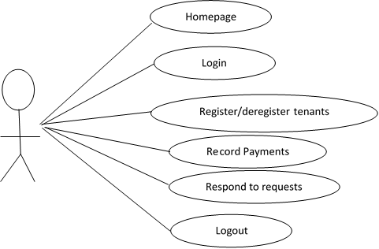

Figure 3.2 use case diagram

### **3.2.3 Data Flow Diagram**

Input tenants details

Admin

Tenant

Payments

Generate reports

D1 Tenants Info

D2 Requests

D3 Payments

Figure 3.3 Data flow diagram

Responds

Requests

Request

Makes

Tenant makes

Details

Details

**Home Page**

The figure below shows the design of the homepage of the developed system. This is the first page which will load whenever someone accesses the site.

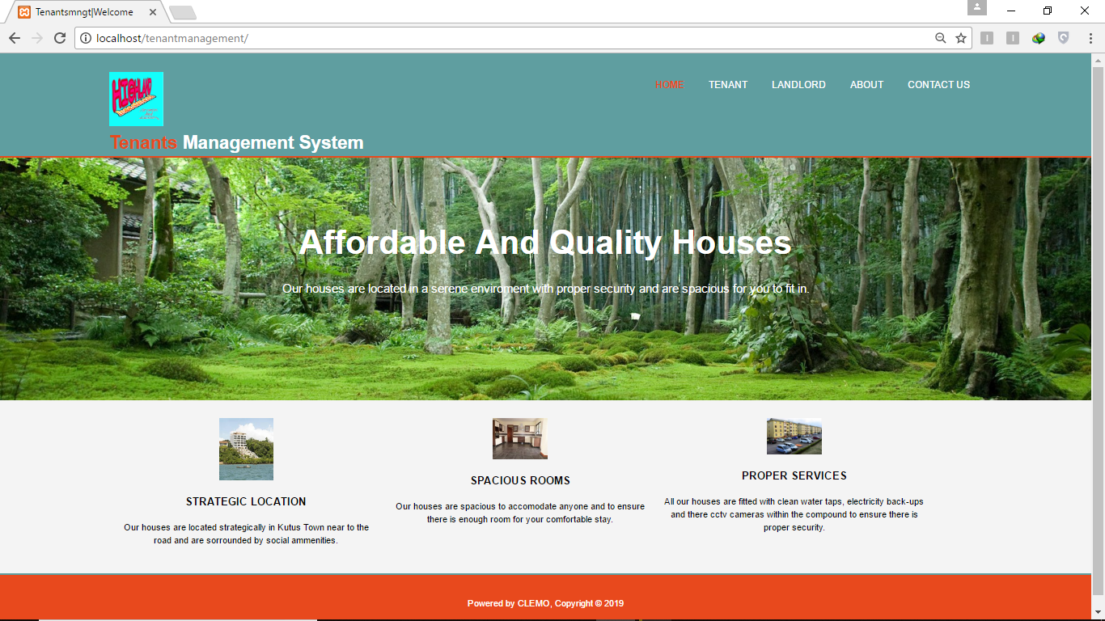

Figure 4.4: Home Page

**Login**

The following is the page design for the landlord to login into the system.

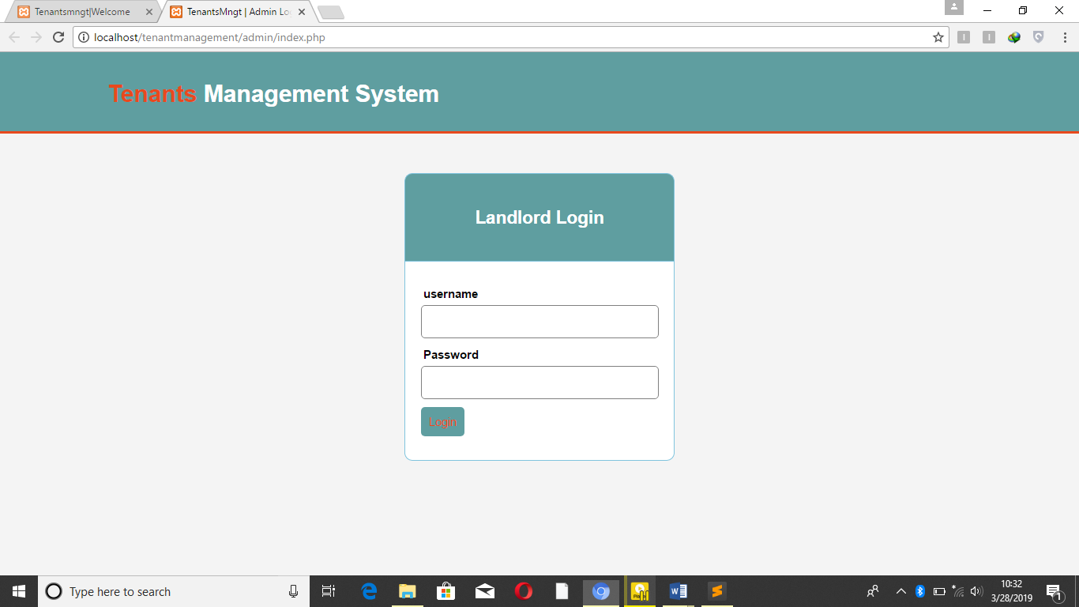

Figure 3.5: Landlord Login

**Landlord Dashboard**

After the landlord has logged in into the system, the following page will pop showing the statistics of the activities taking place in the firm.

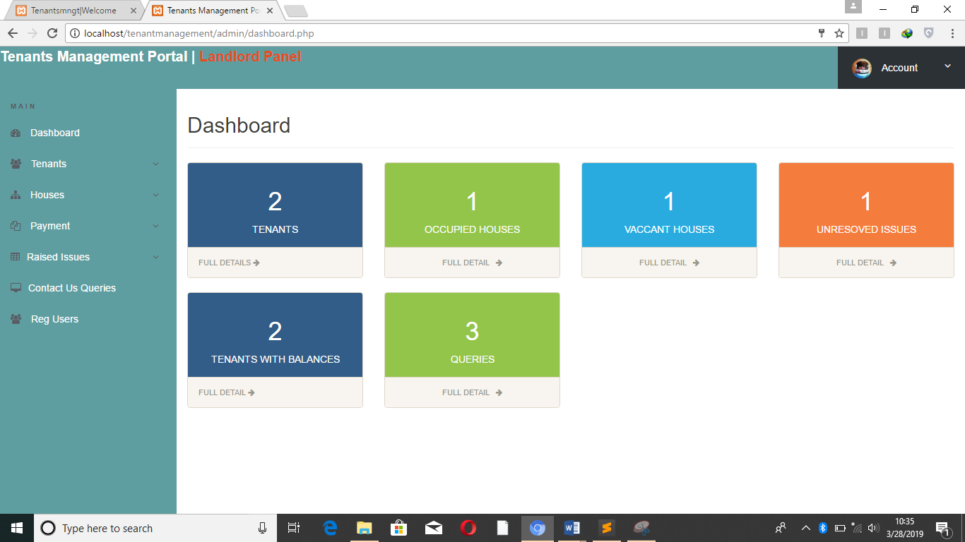

Figure 3.6: Landlord Dashboard

**Tenant Registration**

The following is the design of the page which the landlord will use to register new tenants.

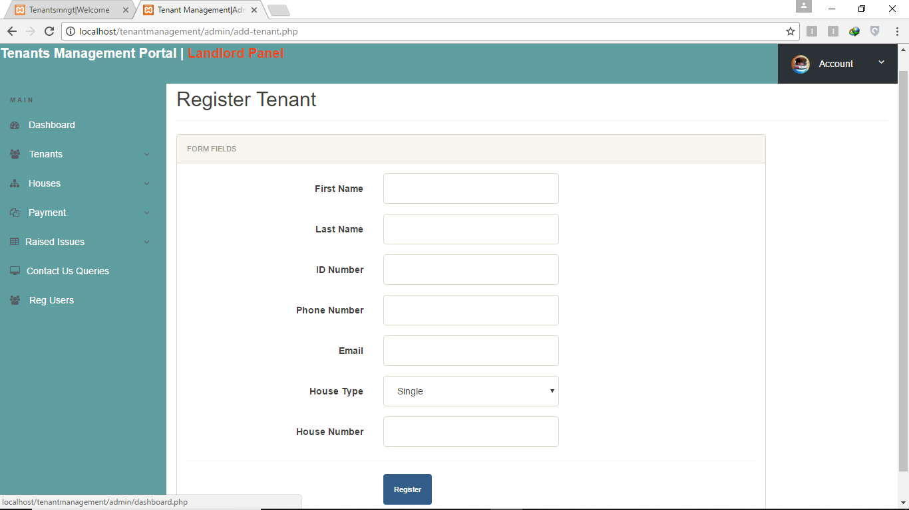

Figure3.7: Tenant Registration

**Payment Recording**

When the landlord is recording payment of rent, the following design will be used.

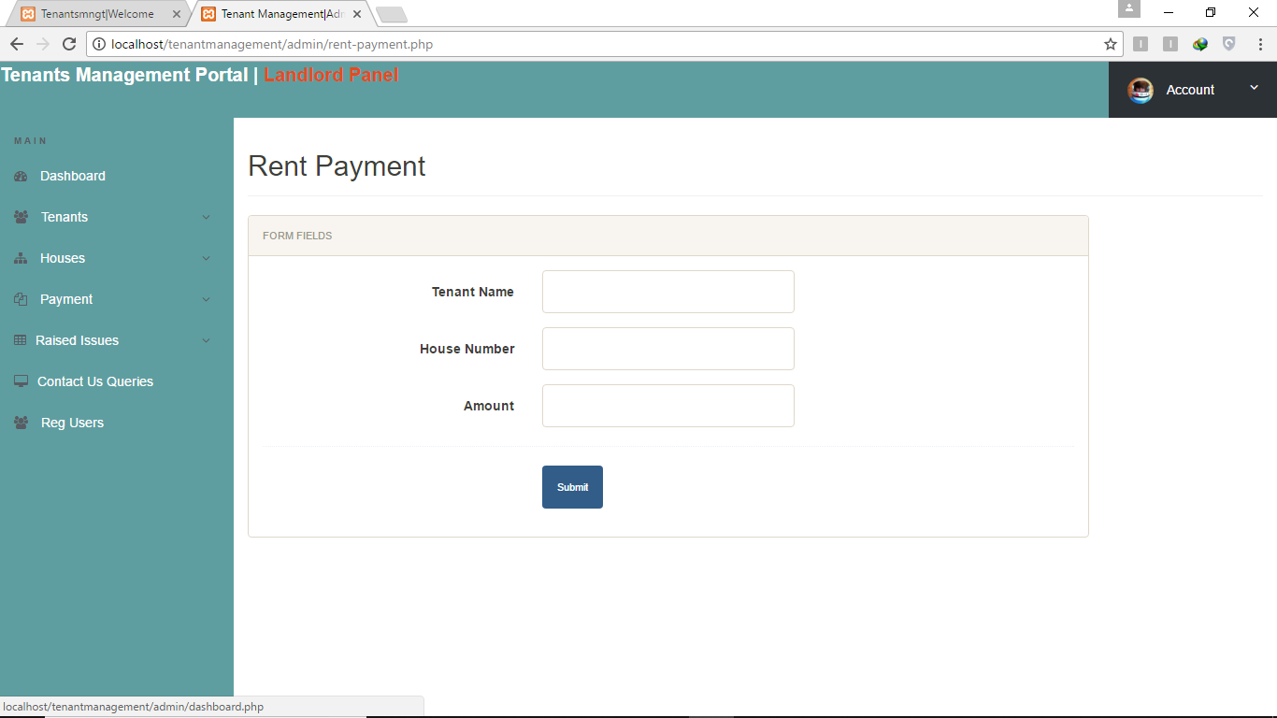

Figure 3.8: Payment recording

**Database**

The figure below shows the list of all the database tables which were used to record the information used in the system.

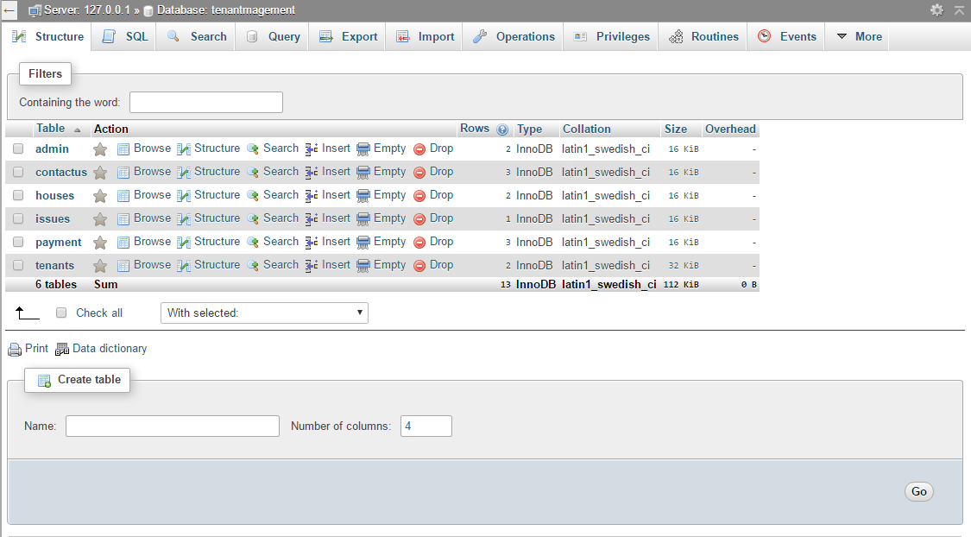

Figure3.9: Database Tables

**Tenants Table**

Table used to record the tenant’s details.

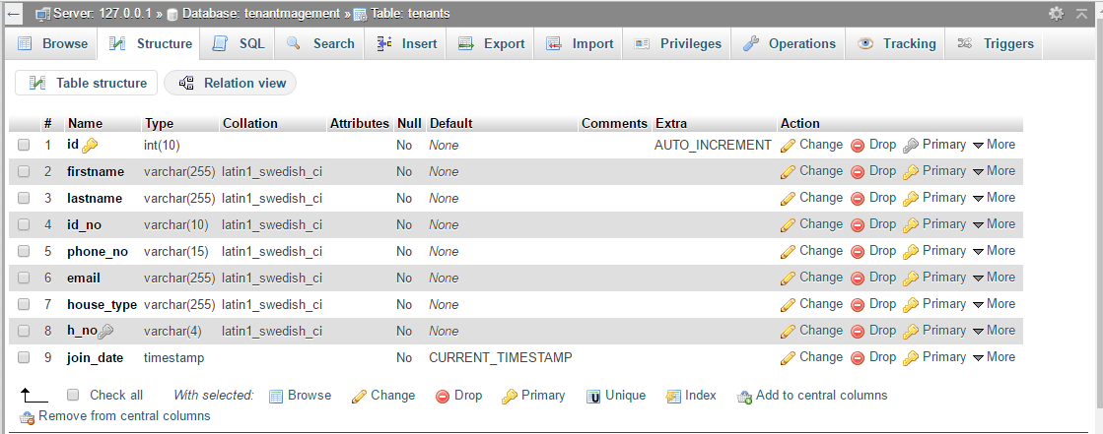

Figure3.10: Tenants table

**Houses Table**

Tenants used to record the details of the houses.

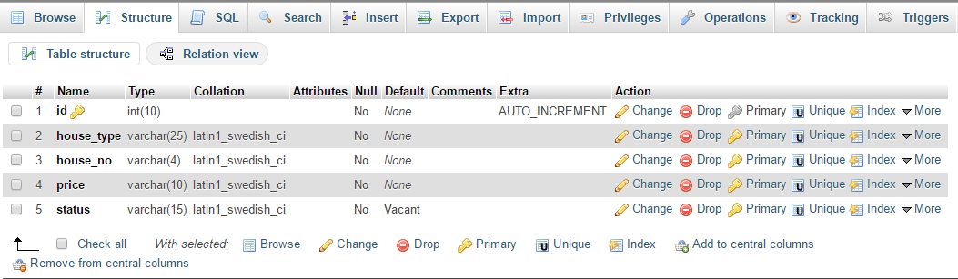

Figure3.11: Houses table

**Payments Table**

Table used to record the payments made by tenants.

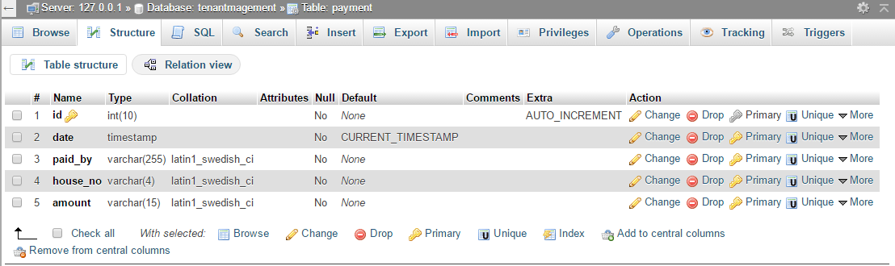

Figure3.12: Payments Table

**Issues Raised Table**

Table used to record issues which have been raised by the tenants.

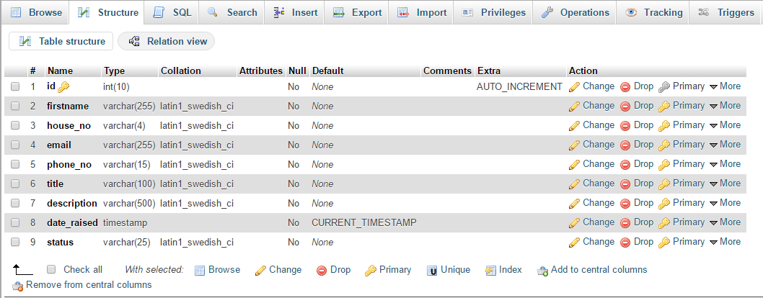

Figure3.13: Issues raised table

# **CHAPTER 4: SYSTEM TESTING AND IMPLEMENTATION**

## **4.1 Unit testing**

The system was developed in units which were later integrated together to work as one system. These units were tested independently. The landlord should be able to add new houses and allocate them to new tenants. The landlord is also able to receive issues which are raised by tenants concerning their stay. The tenant on the other hand upon login should be able to view profile, raise issues and receive communications from the landlord.

## **4.2 Interface Testing**

Below are several tests that were carried out on the interface.

### **4.2.1 Landlord Login**

While login in into the system, the login credentials (username and Password) must match those on the database for it to be successful. If either the username or the password do not match, login will fail and the system will prompt the user to enter the correct credentials.

### **4.2.2 Tenant Registration**

While registering new tenants, the following details are required: the first name, last name, ID number, phone number, valid email address and the house number. Each of these fields must be filled or registration will not take place.

### **4.2.3 Tenant Login**

While login in into the system, the login credentials (email address and ID number) must match those on the database for it to be successful. If either the email address or the ID number do not match, login will fail and the system will prompt the user to enter the correct credentials.

**4.2.4 Payment Recording**

The admin will be able to record payments done by tenants where an email is sent to the respective tenant after successful payment.

### **4.2.5 Integration Testing**

The objective of Integrationtesting is to ensure thataggregates of units performaccurately together. Integration testing should be done independently. The system was tested to ensure all the units worked together in coordination.

## **4.3 System Changeover**

Changeover is the process of changing the old information system. System changeover is the process of putting the new information system online and retiring the old system. The four system changeover approaches include direct cutover, Parallel Operation, Pilot Operation and Phased Operation. Parallel changeover method was applied to while deploying the online tenant management system.

**Parallel Conversion**

A parallel conversion method involves deploying both the existing system and the new system together for a while before getting rid of the old system. This approach was preferred since it is critical to ensure that none of the tenants’ information including the financial statements could get lost during the changeover.

# **CHAPTER 5: CONCLUSION RECOMMENDATION AND FUTURE WORK**

## **5.1 Introduction**

This project has made me integrate all the knowledge that I have acquired in the four years of my course.

To mention a few, the system has enabled me put in practice Software development life cycle from requirements specification to documentation. It has also enabled me to interact and use the various CASE tools that are available to make the whole process easy, understandable and efficient. Among the tools that I have been able to interact with is MySQL Database server, Apache web server and sublime text, which helped me during the coding process. I have also been able to identify most reliable programming tutorial sites such as GitHub, tutorials point and W3SCHOOL

The project has also enabled me write proper software documentation and academic papers especially with the help of my supervisor who insisted on good documentation for an easy to maintain software. The Project have also enabled study jQuery framework and Ajax scripting languages which are not covered in the course syllabus and thus have enabled me to go through a very intensive research on how to come up with a working software inclusive of these scripting languages.

The project has enabled me to explore Open Source Technology which is easy and cheap to implement even big project which would cost a fortune if you were to use the other technologies. Through this I have been able to join in number of forums that involve software development in PHP & MySQL and via this my knowledge of software development has greatly improved to greater heights.

## **5.2 Conclusion**

Online tenant management system will be very useful to renting firms since it will enable landlords and caretakers to manage their tenants’ information in an effective an efficient manner. The system will also make communication between the tenants and management i.e. landlord/caretaker by creating a platform where tenants can raise their issues and receive replies from the management.

## **5.3 Project success**

1. The project allows landlords and caretakers to manage their tenants’ information effectively
2. Communication between the tenants and the management has been made easy.

## **5.4 Limitations**

* Limited time.
* Inadequate Wi-Fi

## **5.5 Recommendation**

This project is subject to improvement based on rising requirements. Even though the project was completed on the base of the requirement that were proposed, the system is very much open to improvement. The following are some of the noted improvements that can be made on the system in future.

* Creating a module where users can review the system and say whether they were satisfied and their needs are met.
* Finally, University should market those projects that are solving a problem in the society.

# **References**

Collins. (2018, Accesed 0ctober 23rd september). *English dictionary*. Retrieved from Collins Dictionary: <https://www.collinsdictionary.com>

eFacility tenant Billing System (2010, january 08). Retrieved from http://www.efacilitybilling.com

KNTBS. (2018, september 08). *KNTBS*. Retrieved from KNTBS: [www.kntbs.co.ke](http://www.kntbs.co.ke)

Malamud, B. (2017). *The tenants.* London: Vintage Digital.

Organisation, W. H. (2005). WHO Library Cataloguing-in-Publication Data. *Manual_on_Management,Maintenance_and_Use_of_Blood_Cold_Chain_Equipment*, 106.

Property Boulevard (2018, september 08). Retrieved from http://www.propertyboulevard.com

Propertyvista management System (2018, september 08). Retrieved from http://www.propertyvista.com

*TANSACS*. (2018, January Tuesday). Retrieved from TANSACS: <https://www.tngovbloodbank.com>

Truerent management System (2018, september 08). Retrieved from http://www.truerentmanagement.com

*Wikipedia*. (n.d.). Retrieved from Wikipedia: https://en.wikipedia.org/wiki/Waterfall model

# **Appendices**

**Sample Page: Home page**

<!DOCTYPE html>

<html>

<head>

<meta charset="utf-8">

<meta name="import" content="width=device-width">

<title>Tenantsmngt|Welcome</title>

<link rel="stylesheet" type="text/css" href="style.css"></head>

<body>

<header>

<div class="container">

<div id="branding">

<img src="./images/Logo.png">

<h1><span class="highlight">Tenants</span> Management System</h1></div>

<nav><ul><li class="current"><a href="index.html">Home</a></li>

<li><a href="tenant.php" target="_blank">Tenant</a></li>

<li><a href="./admin/index.php" target="_blank">Landlord</a></li>

<li><a href="about.html">About</a></li>

<li><a href="contact-us.php">Contact us</a></li></ul></nav>

</div>

</header>

<section id="showcase"><div class="container">

<h1>Affordable And Quality Houses</h1>

<p>Our houses are located in a serene enviroment with proper security and are spacious for you to fit in.</p></div></section>

<section id="boxes"><div class="container"><div class="box"><img src="./images/location.jpg">

<h3>STRATEGIC LOCATION</h3>

<p>Our houses are located strategically in Kutus Town near to the road and are sorrounded by social ammenities.</p></div>

<div class="box"><img src="./images/ampleroom.jpg">

<h3>SPACIOUS ROOMS</h3>

<p>Our houses are spacious to accomodate anyone and to ensure there is enough room for your comfortable stay.</p></div>

<div class="box"><img src="./images/services.jpg">

<h3>PROPER SERVICES</h3>

<p>All our houses are fitted with clean water taps, electricity back-ups and there cctv cameras within the compound to ensure there is proper security.</p></div></div></section>

<footer><div id="copy">

<p>Powered by ASTYLESTATES, Copyright &copy; 2019</p></div>

</footer>

</body>

</html>